

Checklist: yellow fever vaccine
This pre-vaccination checklist assists your healthcare professional to assess the risk of giving you yellow fever vaccine, they must review the checklist to ensure the vaccine is safe for you.
If you have any questions, concerns or do not understand anything please ask your healthcare professional to explain during your consultation.
If you answer ‘yes’ to any questions, you need to give more details during your consultation. To read more about why these questions are important, please see page 3 and page 4 of this form.

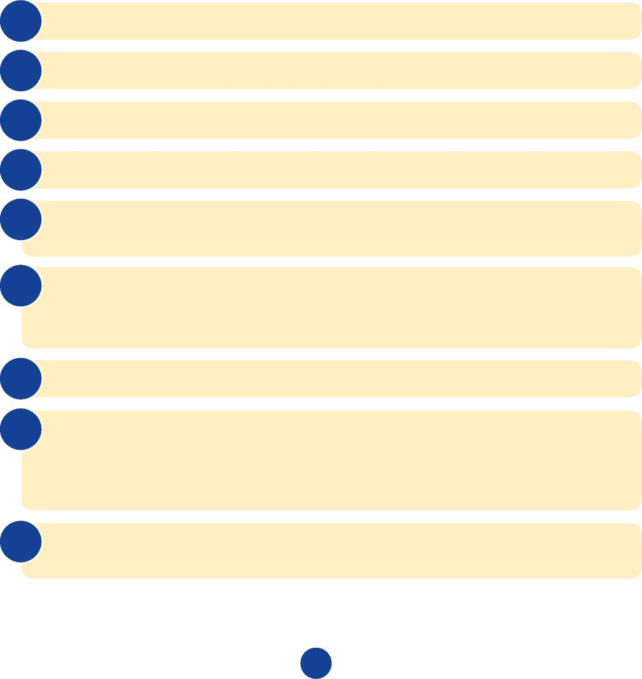
1
Q1 How old are you?
Q2 Are you feeling unwell today? Yes ☐ No ☐
Q3 Do you have any allergies, particularly to eggs or chicken protein? Yes ☐ No ☐
Q4 Have you ever reacted to a previous yellow fever vaccine? Yes ☐ No ☐
Q5 Do you have cancer or have you had cancer in the past
(even if it was a long time ago)? Yes ☐ No ☐
Q6 Do you have any illness that might affect your immune system? Yes ☐ No ☐
For example, leukaemias, lymphoma, cellular immune deficiencies, chronic lymphoproliferative conditions, or if you have ever received a stem cell transplant.
Q7 Are you living with HIV? Yes ☐ No ☐
Q8 Are you taking any medicines (now or within the last year) that affect
your immune system? Yes ☐ No ☐
For example, steroids, biological or non-biological immune modulating medicines, treatment following an organ transplant.
Q9 Are you having chemotherapy or radiotherapy (now or within
the last year)? Yes ☐ No ☐

! I have read the above and confirm that the questions have been answered to the best of my knowledge.


Q10 Have you ever been told that you may have a problem with
your thymus gland (includes myasthenia gravis or a thymoma)? Yes ☐ No ☐
Q11 Have you had an operation to remove your thymus gland
(thymectomy) for any reason including during cardiac surgery? Yes ☐ No ☐
Q12 Have you ever had open chest surgery? Yes ☐ No ☐
Q13 Are you pregnant or planning a pregnancy? Yes ☐ No ☐
Q14 Are you breast feeding? Yes ☐ No ☐
Q15 Do you have a first-degree family relative (i.e. a blood relative – mother, father, full brother, sister or child) who has had a serious
adverse reaction to yellow fever vaccine? Yes ☐ No ☐
Name of patient Signature of patient Date (dd/mm/yy)
If applicable
Name of parent/guardian Signature of parent/guardian Date (dd/mm/yy)
Form reviewed and risk assessment carried out by
Reviewed by Qualifications Date (dd/mm/yy)

2


Why are these questions important?

3

How old you are
Babies
- There is a greater risk of yellow fever vaccine related brain inflammation (encephalitis) in very young babies. Babies aged less than six months should not have yellow fever vaccine and babies aged six to nine months should only be given this vaccine if the risk of yellow fever at the destination to be visited is high, such as during epidemics/ outbreaks, and travel is unavoidable.
Aged 60 years or older
- You are at increased risk of developing serious side effects from the vaccine compared to younger travellers. If you are travelling to areas where yellow fever vaccine is ‘generally not recommended’ you should not receive vaccine. Further information is available in the NaTHNaC Yellow Fever Information Leaflet for Travellers and on the FitForTravel Yellow Fever Vaccine page.
How you are feeling today
- Minor illness without high temperature (fever) should not usually delay your yellow fever vaccination. However, vaccination may be postponed until you have fully recovered. This is to make sure any symptoms are not confused with possible reactions to the vaccine.
Your allergies and previous reactions to yellow fever vaccine
- This vaccine may contain traces of egg, chicken protein and other ingredients that some people are occasionally allergic to. If you have ever had a serious reaction (anaphylaxis) to any of the vaccine ingredients, you must tell your health professional; you will not usually be able to receive yellow fever vaccine.
Your general health and any condition or treatment that may affect your immune system
- This vaccine contains live yellow fever virus that has been weakened. Your response to the vaccine may not be so good if your immune system is weakened by certain illnesses or treatments, but occasionally the vaccine can still be given. However, if your immune system is very weak you must not receive yellow fever vaccine as you are at risk of developing serious side effects from the vaccine, including death.
If you have ever been told that you may have a problem with your thymus gland (includes myasthenia gravis or a thymoma), or if you ever had open chest surgery
- The thymus gland is part of your immune system and sometimes does not work properly or has been removed (thymectomy). Myasthenia gravis is a disease that may involve your thymus gland. If you have a history of any of these conditions, you must not receive yellow fever vaccine as you are at risk of developing serious side effects, including death.
- The thymus gland may be removed during chest surgery. Yellow fever vaccine can still be given in some instances following chest surgery.
If you are planning a pregnancy, pregnant now or breast-feeding
- If you are planning a pregnancy, it is recommended to wait until 28 days after yellow fever vaccination before getting pregnant (conceiving).
- Safety of yellow fever vaccine during pregnancy is not clear, although increased complications for mother or baby have not been reported when the vaccine was given during pregnancy. Discussion with a health professional about the risks and benefits of this vaccine during pregnancy will help you decide whether yellow fever vaccination is right for you at this time.
- You are encouraged to continue breast-feeding during your trip. Several very young (less than two months old) breast-fed babies developed brain inflammation shortly after their mothers’ yellow fever vaccination. Discuss with a health professional whether the risk of yellow fever at your travel destination is sufficiently high for yellow fever vaccination to be recommended.
If you have a first-degree family member who has had a serious adverse reaction to yellow fever vaccine
- If such a reaction was not due to a known medical risk factor, it is possible that you may be susceptible to developing a serious adverse reaction due to an unidentified genetic reason.

! If you cannot have the yellow fever vaccination, and travel to areas where yellow fever occurs cannot be avoided, you still need advice about yellow fever certificate requirements and how to avoid mosquito bites.
Please check the following websites for further information and updates:
- TravelHealthPro – www.travelhealthpro.org.uk/countries
- Fit for Travel – www.fitfortravel.nhs.uk/yellow-fever-vaccine
For healthcare professionals:
- TravelHealthPro – www.travelhealthpro.org.uk
- TRAVAX (Scotland) – www.travax.nhs.uk/yellow-fever
First published September 2021

4

